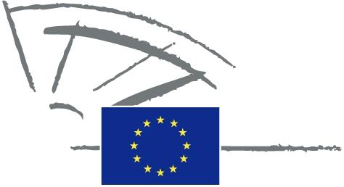
 | EUROPEAN PARLIAMENT | 2009 - 2014

<Date>{09/05/2011}9.5.2011</Date> <NoDocSe>0022/2011</NoDocSe>
<TitreType>WRITTEN DECLARATION</TitreType>
<TitreRecueil>pursuant to Rule 123 of the Rules of Procedure</TitreRecueil>
<Titre>on epilepsy</Titre>
<Depute>Gay Mitchell, Nirj Deva, Marian Harkin, Peter Skinner, Angelika Werthmann</Depute>
Lapse date: <DateForclusion>{15/09/2011}15.9.2011</DateForclusion>

0022/2011
Written declaration on epilepsy
The European Parliament,
– having regard to Rule 123 of its Rules of Procedure,
A. whereas epilepsy is the most common serious disorder of the brain,
B. whereas 6 000 000 people in Europe have epilepsy, with 300 000 new cases diagnosed each year,
C. whereas up to 70% of people with epilepsy could be seizure-free with appropriate treatment, while 40% of people with epilepsy in Europe do not receive such treatment,
D. whereas 40% of children with epilepsy have difficulties at school,
E. whereas people with epilepsy in Europe experience high levels of unemployment,
F. whereas people with epilepsy are exposed to stigma and prejudice,
G. whereas epilepsy damages health but also disrupts every aspect of life, and can impose physical, psychological and social burdens on individuals and families,
1. Calls on the Commission and Council to:
– encourage research and innovation in the area of prevention and early diagnosis and treatment of epilepsy;
– prioritise epilepsy as a major disease that imposes a significant burden across Europe;
– take initiatives to encourage Member States to ensure equal quality of life, including in education, employment, transport and public healthcare, for people with epilepsy, e.g. by stimulating the exchange of best practice;
– encourage effective health impact assessments on all major EU and national policies;
2. Calls on the Member States to introduce appropriate legislation to protect the rights of all people with epilepsy;
3. Instructs its President to forward this declaration, together with the names of the signatories, to the Commission and the Parliaments of the Member States.

