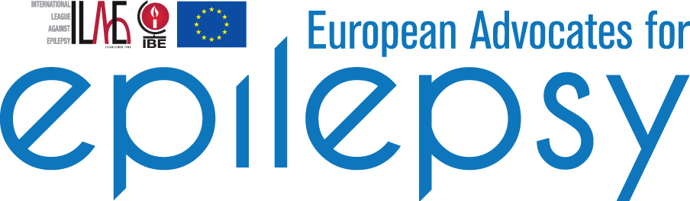
Terms of Reference
The European Advocates for Epilepsy Working Group is a group of cross‐party, cross‐national MEPs with particular interest in epilepsy. The group has a President who chairs the Group and can have up to four Vice-Presidents, who are elected by the members of the group. The President for the term 2014-2019 is Mr Brian Hayes MEP with Vice-President Mrs Nathalie Griesbeck MEP.
Mission Statement
The aim of the European Advocates for Epilepsy Working Group is to improve the quality of life of all people with epilepsy, their families, care‐givers and healthcare providers through European Union (EU) policy.
In particular, by providing a network for the exchange of experience, information and data on epilepsy between all interested stakeholders, the European Advocates for Epilepsy Working Group serves to:
- introduce impetus to the development, introduction and implementation of a targeted EU epilepsy strategy, in the form of an EU Council Recommendation on epilepsy diagnosis, management, education and research;
- address specific EU and national policies which have a potential positive or negative impact on the lives of people with epilepsy.
Policy Objectives
The key policy objectives of the European Advocates for Epilepsy Working Group are:
- Public Health: to have epilepsy viewed as an EU public health priority and support crosssectoral policies and legislation that promote awareness, diagnosis and management of the disease;
- Research: to secure increased funding and improved coordination in epilepsy research;
- Education: to ensure that the general population, including people with epilepsy, have clear and accurate information on epilepsy;
- Employment & social affairs: to support EU policies and legislation that prevent discrimination against people with epilepsy in all aspects of their lives, including education and employment;
- Rights of persons with epilepsy: to ensure that EU healthcare policies and legislation adequately safeguard the rights and safety of persons with epilepsy.
Structure and Membership
Members of the European Advocates for Epilepsy Working Group commit to provide the following support over the period 2014‐2019:
- Attending meetings of the European Advocates for Epilepsy Working Group on a regular basis – approximately three times each year;
- Providing advice to the epilepsy community on how best to advance their policy objectives both in the European Parliament and more widely;
- Participating in roundtable or discussion groups in the European Parliament, and in member states, to address those problems faced by people with epilepsy and to advocate new policy initiatives;
- Sharing information with colleagues at both EU and national levels;
- Supporting the epilepsy community in shaping policies that will impact positively on epilepsy by tabling amendments, oral or written questions and resolutions; by communicating with relevant Commissioners; and by organising targeted events on specific policy issues.

MEPs who become members of the European Advocates for Epilepsy Working Group receive a certificate confirming their membership as well as regular updates on important developments in the field of epilepsy policy.
September 2014

